|  |
| --- |
| [Company name] |
| Import Data in Power BI Desktop |
| [Document subtitle] |

|  |
| --- |
| Steven Renders  [Date] |

Table of Contents

Step 01 Import Data in Power BI Desktop – GUIDE 2

Locate Files 2

Get Data 2

Determine Column Names 2

Verify and update the data types 4

Remove Columns 5

Query Naming 7

Close and Apply 7

Repeat for all files to import 8

Save Power BI Desktop file 9

# Step 01 Import Data in Power BI Desktop – GUIDE

## Locate Files

In this step you import the following excel files into Power BI Desktop:

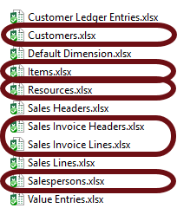

Only import the marked files. They should be in this folder: C:\temp\Power BI Hands-On Workshop

## Get Data

In the Home tab, select Get Data, Excel. Then browse for the Excel file and import it. In the window that opens, select the sheet with the data and then click the Edit button:

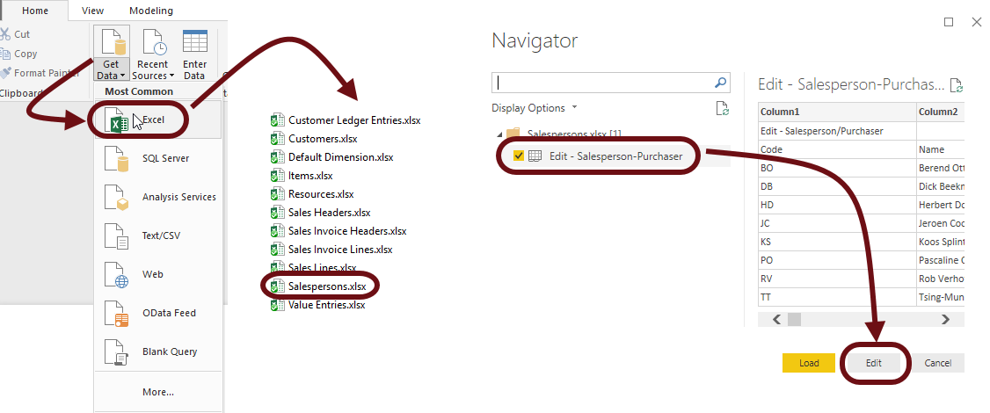

## Determine Column Names

Depending on which Excel file you select, the first row either contains the column names or not. In the below example you need to remove the first row:

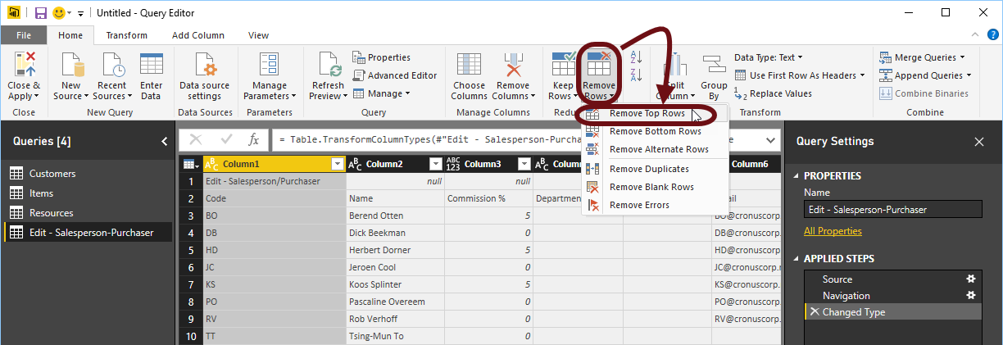

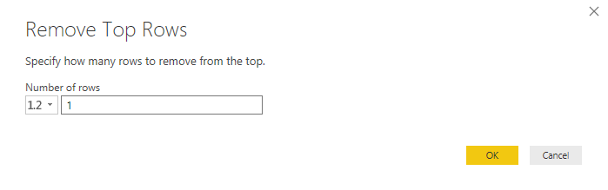

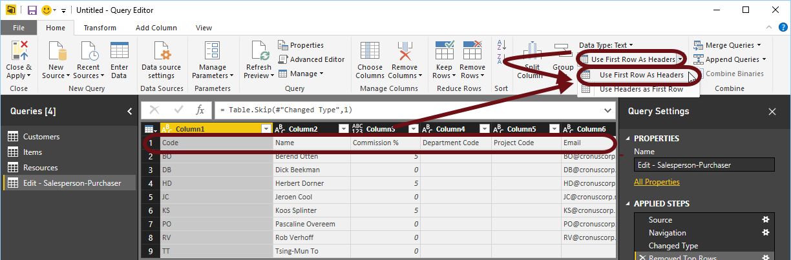

The result looks as follows:

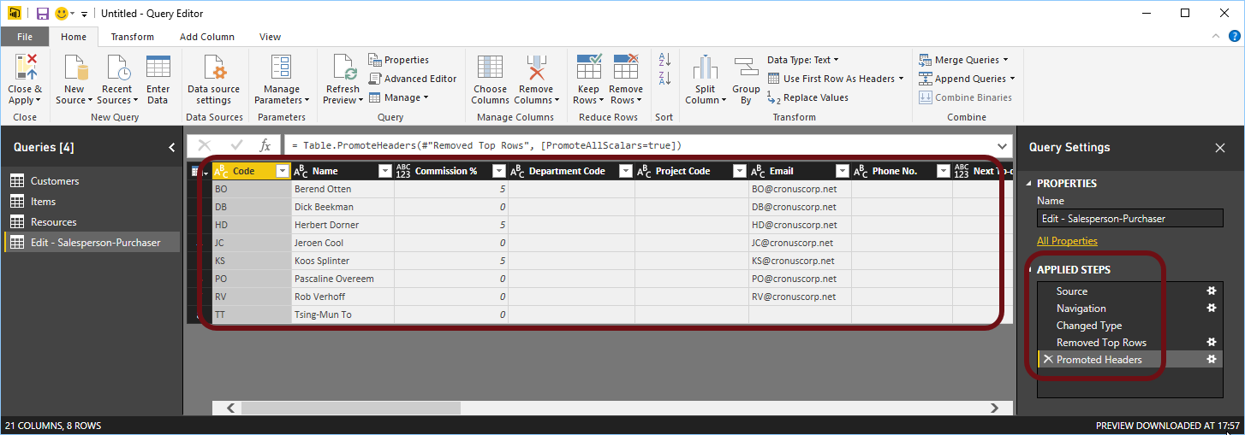

On the right side you can see the applied steps, in the order they were applied.

Some of the excel files do not require you to remove the first row and use the second row as the header.

## Verify and update the data types

Now that you have imported the excel table you need to verify and update the data types, for all columns. Columns that contain numeric data should be marked as Decimal or Whole numbers, dates as Date and the other columns as Text.

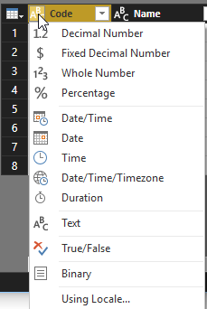

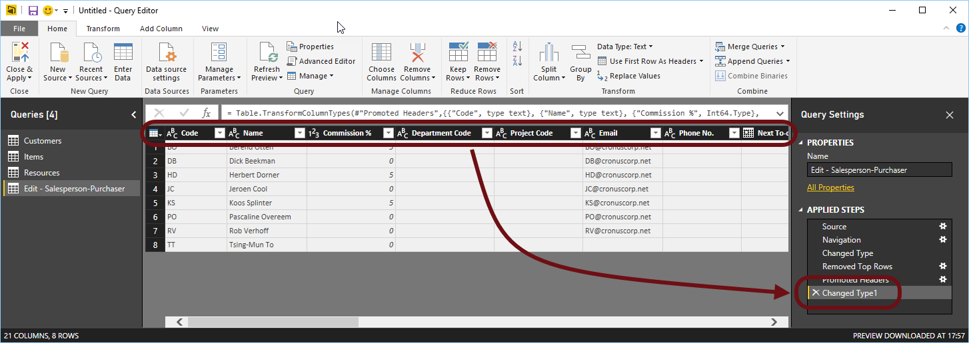

## Remove Columns

Columns that are empty, or that are not required can be removed, as follows:

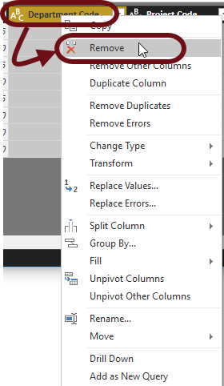

Repeat this for every column that needs to be removed. As an alternative, select the Choose Columns button, to select the columns you want to keep:

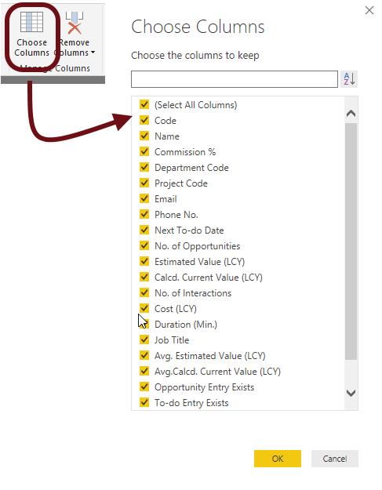

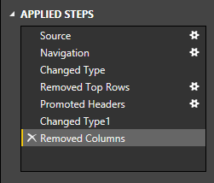

## Query Naming

Now rename the query:

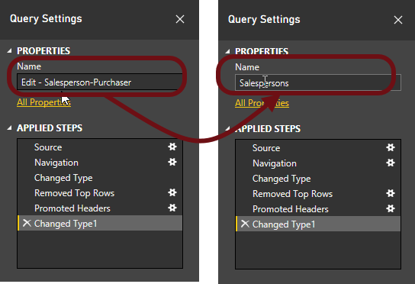

## Close and Apply

You are now ready to Close and Apply your changes:

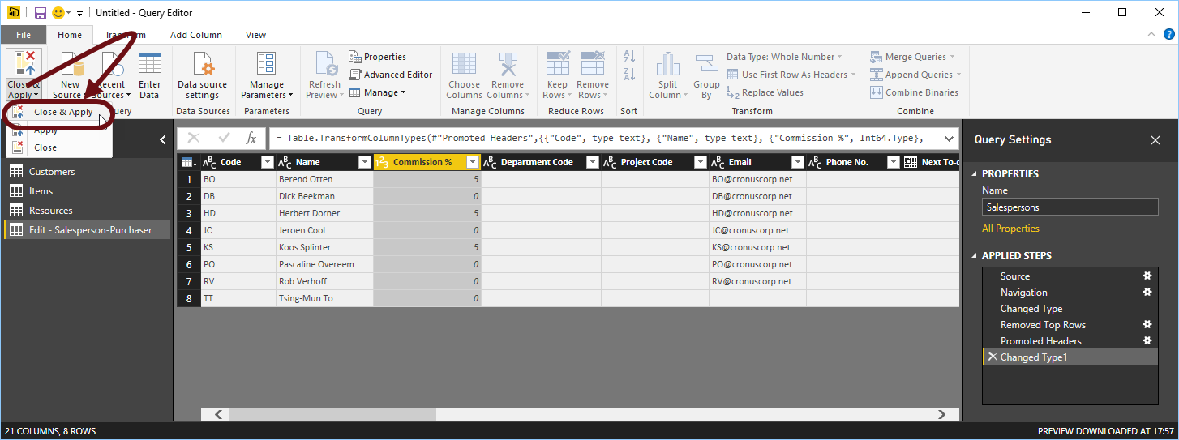

In the diagram window you can see the result:

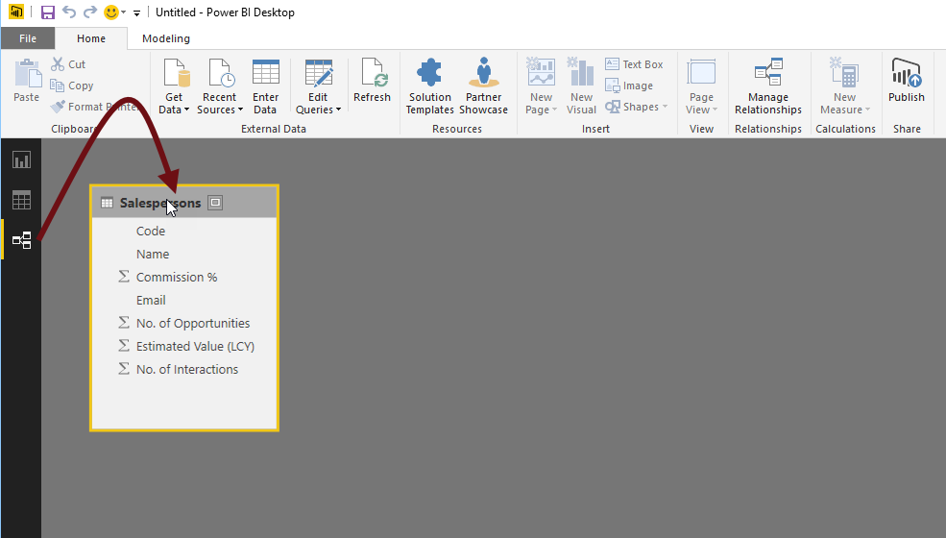

## Repeat for all files to import

Repeat this for the other excel files.

At the end of this step your diagram should look, similar to, the following:

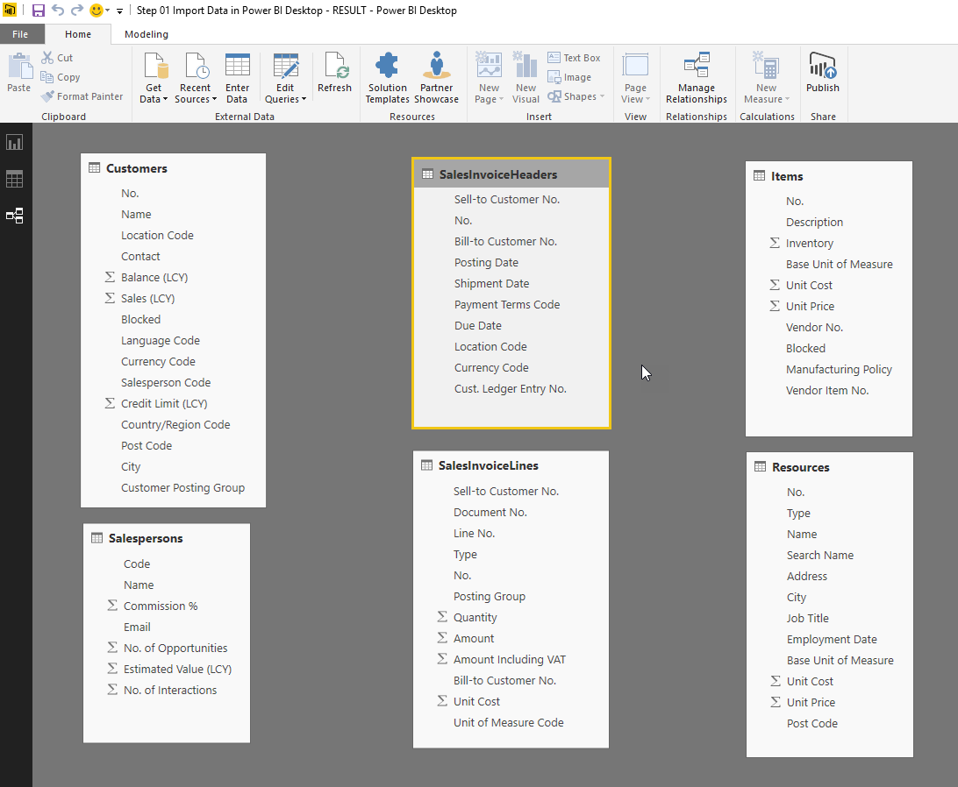

In case there are any yellow lines, connecting tables, delete them. Select the line and click the delete button.

## Save Power BI Desktop file

Save your .pbix file.

